NAAN MUDHALVAN ARTS INTERNSHIP PROGRAM 2026
Frontend Web Development using React
Project Submission

STUDENT NAME : SARAVANAN C
YEAR : 3RD YEAR
COLLEGE CODE : BRUAU
COLLEGE NAME : GOVERNMENT ARTS AND SCIENCE COLLEGE AVINASHI (COEDUCATION)
DEPARTMENT : B.Sc (COMPUTER SCIENCE)
SEMESTER : IV SEMESTER
ROLL NO : 2422K1184
NMID : BDAF41868EB0ABCA173447F5B2B1225B

DATE : 18/06/2026
TITLE: JOB PORTAL WITH SEARCH & FILTERS
GITHUB LINK : https://github.com/saravanansaro27/NM-internship.git

1.ABSTRACT
HireHub AI is a React-based job portal designed to help students and job seekers find suitable career opportunities. The platform provides job search and filtering features, AI-based job recommendations, job bookmarking, career roadmaps, and placement statistics. It offers a simple and interactive interface that helps users explore jobs, save opportunities, and gain career insights. The project is developed using React.js, JavaScript, HTML, and CSS to demonstrate modern web development and improve the job search experience.

2.PROBLEM STATEMENT
Many students and job seekers struggle to find suitable job opportunities due to scattered job information and lack of personalized career guidance. Traditional job portals often provide limited recommendations and do not help users identify relevant skills or career paths. There is a need for a smart platform that can simplify job searching, provide AIbased recommendations, and assist users in making better career decisions through an easy-to-use interface.

3.OBJECTIVES
To develop an AI-powered job portal for students and job seekers.
To provide job search and location-based filtering features.
To offer AI-based job recommendations based on skills.
To enable users to save and manage preferred job opportunities.
To provide career insights, trending skills, and career roadmaps.
To create a user-friendly and responsive web application using React.js.

4.PROJECT SCOPE
The scope of HireHub AI is to provide a web-based platform that helps students and job seekers search for jobs, receive AI-based recommendations, and access career guidance. The system includes job filtering, job bookmarking, placement statistics, trending skills, and career roadmap features. It aims to simplify the job search process and improve career planning through an interactive and user-friendly interface developed using React.js.

5. TECHNOLOGIES USED
React.js– For building the user interface and components.
JavaScript (ES6)– For application logic and interactivity.
HTML5– For structuring web page content.
CSS3 – For styling and responsive design.
VS Code – As the development environment.
Git & GitHub– For version control and project management.

6. APPLICATION FLOW
User opens the HireHub AI application.
The homepage displays job listings, placement statistics, and career insights.
The user searches and filters jobs based on role and location.
Matching jobs are displayed dynamically.
The user can view detailed job information.
The user can save preferred jobs for future reference.
AI-recommended jobs are displayed based on skills.
The user can explore trending skills, career roadmaps, and resume insights.

7. KEY REACT CONCEPTS USED
Functional Components – Used to create reusable UI components.
JSX (JavaScript XML)– Used to write HTML-like code within JavaScript.
useState Hook – Used for managing search, location filters, saved jobs, and selected job states.
Event Handling – Used for button clicks, search inputs, and navigation actions.
Conditional Rendering– Used to display saved jobs and job details dynamically.
List Rendering (map) – Used to display job cards from the jobs array.
Props and State Management – Used for handling and updating application data.
Filtering and Dynamic Rendering – Used to show jobs based on user search and location filters.

8. CHALLENGES FACED
Implementing dynamic job filtering based on search and location.
Managing application state using React Hooks (`useState`).
Preventing duplicate job bookmarks in the saved jobs section.
Creating responsive layouts that work on different screen sizes.
Implementing conditional rendering for job details and saved jobs. Designing a user-friendly and visually appealing interface.

9. EXPECTED OUTPUT

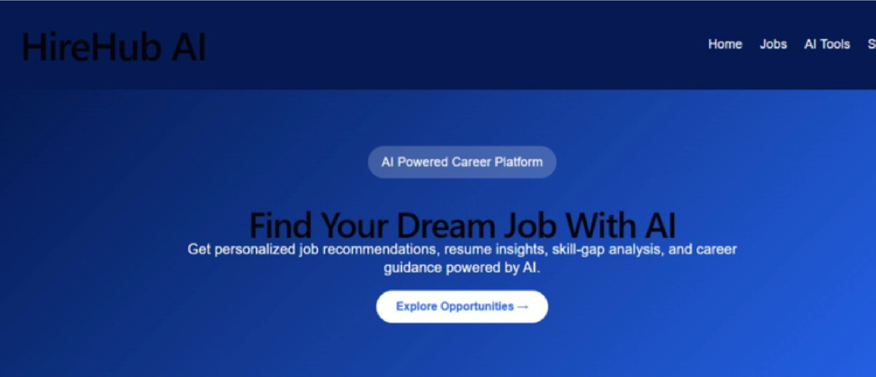
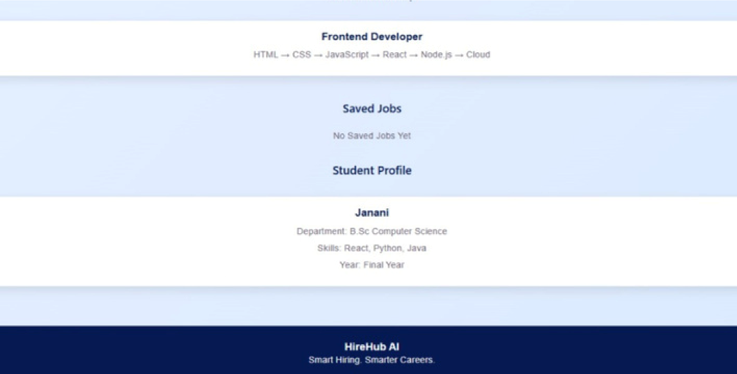
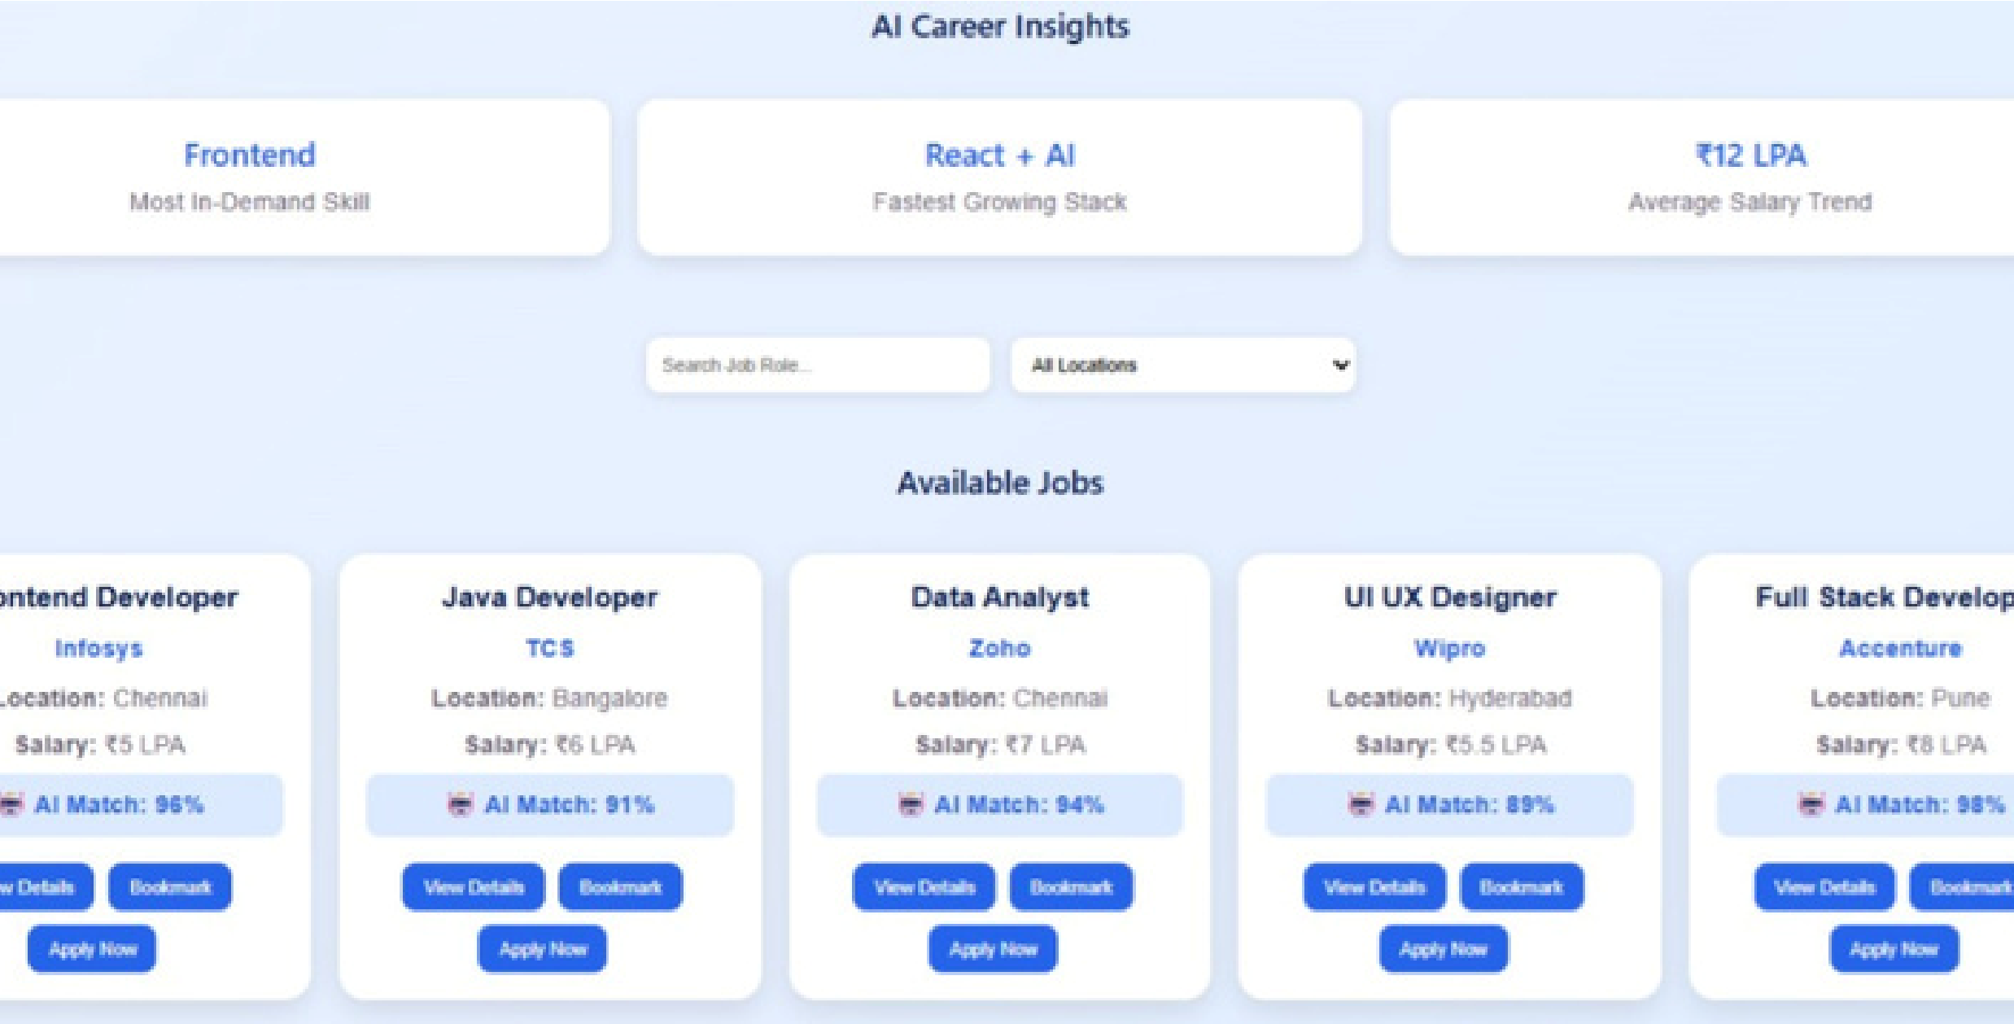
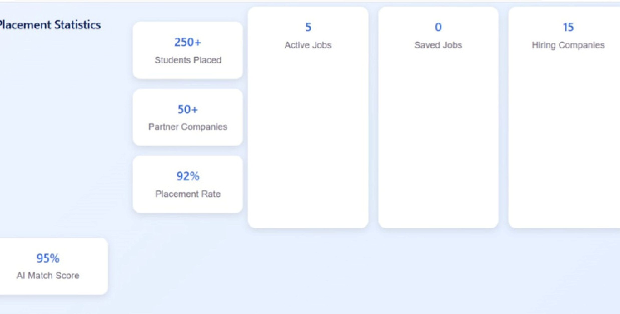

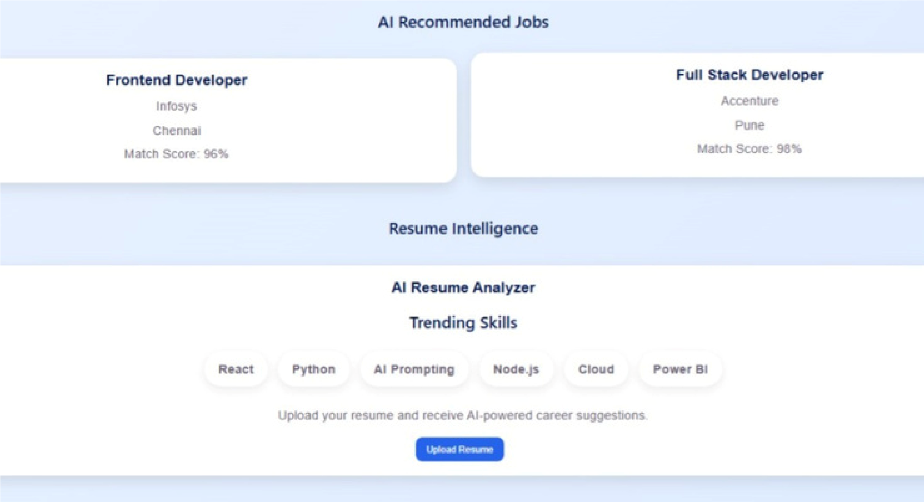

10. LEARNING OUTCOMES
Gained practical experience in developing web applications using React.js.
Learned to use React Hooks (`useState`) for state management.
Improved understanding of JSX, event handling, and conditional rendering.
Developed skills in creating responsive user interfaces using CSS.
Learned how to implement job filtering, bookmarking, and dynamic content rendering. Enhanced problem-solving and debugging skills during project development.

11. CONCLUSION
HireHub AI is a user-friendly job portal that helps students and job seekers explore career opportunities efficiently. The project successfully implements job search, filtering, bookmarking, and AI-based recommendations using React.js. It demonstrates modern frontend development concepts and provides a foundation for future enhancements such as resume analysis, authentication, and backend integration.

